***Report of the Mini Project Done in Partial Fulfilment of the Requirements for the Award of***

***Degree of Bachelor of Technology in Electronics and Communication Engineering***

**ZEPHYR**

**MINI PROJECT REPORT**

*Done by*

**Binu Ajmal Shah Reg No: AJC21EC034**

**Denil C Varghese Reg No: AJC21EC038**

**Joel Jackson John Reg No: AJC21EC048**

*Under the guidance of*

**Dr. Careena P**

Asst. Professor, Dept of ECE



**Bachelor of Technology in**

**Electronics & Communication Engineering Department of Electronics & Communication Engineering**

**Amal Jyothi College of Engineering**

**(Affiliated to APJ Abdul Kalam Technological University, Thiruvananthapuram) Kanjirapally – 686518**

**May-2024**

**DEPARTMENT OF ELECTRONICS & COMMUNICATION ENGINEERING**

**AMAL JYOTHI COLLEGE OF ENGINEERING**

**(Affiliated to APJ Abdul Kalam Technological University) Kanjirapally – 686518**



# BONAFIDE CERTIFICATE

This is to certify that the mini project report entitled **“ZEPHYR”** is a Bonafide report of the Sixth Semester Mini Project [ECD334] done by **Binu Ajmal Shah, Reg No: AJC21EC034; Denil C Varghese, Reg No: AJC21EC038; Joel Jackson John, Reg No: AJC21EC048;** in partial fulfilment of requirements for the award of degree of Bachelor of Technology in Electronics and Communication Engineering from APJ Abdul Kalam Technological University, on April 2024. They have done the mini project with prior approval from the department.

|  |  |
| --- | --- |
| **Dr. Careena P** | **Mr. Abubeker K M** |
| Project Guide | Project Coordinator |
| Asst. Professor | Asst. Professor |

**Dr. Geevarghese Titus**

Head of the Department

# ACKNOWLEDGEMENT

First, we sincerely thank the **Almighty** who is most beneficent and merciful for giving us the knowledge and courage to complete the mini project successfully.

We derive immense pleasure in expressing our sincere thanks to the Principal **Dr. Lillykutty Jacob,** for her permission and for providing infrastructural facilities for the successful completion of our work of the mini project.

We express our gratitude to **Dr Geevarghese Titus**, Head of the Department, ECE, for his encouragement and motivation during our work of the mini project. We express our heartfelt gratefulness to **Mr.Abu Beker K.M,** Assistant Professor, Department of ECE, project guide, for his valuable guidance and suggestions during the project.

We also extend our sincere thanks to **Dr. Careena P** Assistant Professor, Department of ECE for her kind support and coordination.

Finally, we appreciate the patience and solid support of our parents and enthusiastic friends for their encouragement and moral support for this effort.

Binu Ajmal Shah

Denil C Varghese

Joel Jackson John

# ABSTRACT

Top of Form

In recent years, the importance of air quality monitoring has risen, complementing traditional weather monitoring. This abstract introduces an innovative approach merging air quality measurement with conventional weather stations for a more comprehensive environmental assessment. The system integrates standard weather sensors with advanced air quality modules, including particulate matter (PM), volatile organic compound (VOC), nitrogen dioxide (NO2), and sulfur dioxide (SO2) sensors. This amalgamation allows real-time tracking of air quality alongside temperature, humidity, pressure, and precipitation.

By combining weather and air quality data, this system offers profound insights into the interaction between meteorological factors and air pollution, facilitating pollution source identification and assessing environmental changes' impact on air quality and human health. Furthermore, the collected data can inform urban planning, public health management, pollution control, and climate change mitigation strategies. Real-time data accessibility supports timely interventions to mitigate environmental impacts.

In summary, integrating air quality measurement into weather stations represents a significant advancement in environmental monitoring technology. This integration empowers researchers, policymakers, and stakeholders with a nuanced understanding of environmental conditions, fostering more effective strategies for preserving air quality and protecting human health in our rapidly evolving world.

**TABLE OF CONTENTS**

i. ACKNOWLEDGEMENT…………………………………………………………..i

ii.ABSTRACT………………………………………………………………………..ii

1. INTRODUCTION…………………………………………………………………1

2. LITERATURE SURVEY…………………………………………………………2

3. ZEPYHR ……………………………………….....................................................5

3.1 System Modeling…………………………………………………………...........5

3.2 Description of System Components……………………………………………...6

3.3 Circuit Diagram…………………………………………………………..............8

3.4 Description of Circuit Diagram……………………………………………..8

3.5 Cost of Materials…………………………………………………………......9

4. RESULT……………………………………………………………………….....10

5,CONCLUSION…………………………………………………………….……..11

REFERENCES………………………………………………………………….....12

APPENDIX………………………………………………………………………………..13

# LIST OF FIGURES

Figure 3.1: Block Diagram of the Proposed System............................................5

Figure 3.2: ESP-32..............................................................................................6

Figure 3.3: MQ-135.............................................................................................6

Figure 3.4: DHT-11 ......................................................................…......……….7

Figure 3.5: LCD Display......................................................................................7

Figure 3.8: Circuit Diagram…………………………...……………………….….……9

**LIST OF TABLES**

Figure 3.5: Cost of Materials……………………………………………………1

# CHAPTER 1

# INTRODUCTION

The primary goal is to create a sophisticated, adaptive, and connected system that goes beyond traditional fire detection methods . By empowering users with timely information, the system aims to facilitate effective decision-making during emergencies, contributing to enhanced overall safety and well-being. Additionally, it incorporates a weather station to enhance fire risk assessments and improve overall safety measures. It aims to empower users with timely information for effective decision-making during emergencies.

The objective of the pollution detection and notification system using ESP32 is to create a device capable of monitoring air quality and alerting users when pollution levels exceed predefined thresholds. It also displays temperature, humidity. Receives the notification on mobile phones.

IoT Connectivity: The novelty of the above smoke detector lies in its integration of modern IoT technology, specifically the ESP32 microcontroller, for efficient smoke detection and alerting. Real-time Data Visualization: Develop a real-time data visualization dashboard, providing users with graphical representations of air quality, temperature, and other relevant data captured by the smoke detector.

**CHAPTER 2**

**LITERATURE SURVEY**

**[1]. Mohamad Syafiq Mohamad Adenan, et al. “*Smart Smoke Detector*”,** [**https://doi.org/10.36079/lamintang.ijortas-0301.198**](https://doi.org/10.36079/lamintang.ijortas-0301.198)**, March 2021**

In recent decades, numerous studies have focused on enhancing security systems across various domains. A critical challenge faced by security measures is the threat of fire outbreaks in diverse settings such as homes, schools, and factories. To address this concern and mitigate potential damages, the integration of Internet of Things (IoT) technology has become pivotal. This modern system utilizes sensors and switches interconnected for efficient monitoring. Employing an Arduino device alongside a temperature sensor (Flame sensor), this project aims to promptly detect and measure heat intensity in the event of a fire, serving as an early alarm system. This proactive approach is crucial given the time constraints associated with traditional fire station response times. The sensors play a pivotal role in providing timely notifications to mobile phones, enabling swift and informed action to prevent extensive damage in the event of a fire outbreak.

**[2]. Nikhil Komalapati, et al. “*Smart Fire Detection and Surveillance System Using IOT*”, 2021 International Conference on Artificial Intelligence and Smart Systems (ICAIS)**

Fire stands as the most prevalent cause of tragic fatalities, resulting in numerous injuries and a significant surge in death tolls annually. The proposed detection system aims to safeguard individuals from fire hazards by triggering an alarm during emergencies. This involves sending warning messages to a Telegram account, identifying ESP32 movements online and notifying cellphone users. Customization is achieved through the Arduino IDE. A Telegram bot, created for ESP32, utilizes PIR sensors to issue warning messages via a Telegram account, detecting any movement. Additionally, fire sensors identify visual cues and temperature changes to activate alarms through the Telegram channel.

**[3]. Uddesh U Naik et al. *“Iot Based Air Pollution Monitoring System*”, International Journal of Scientific Research & Engineering Trends Volume 9, Issue 3, May-Jun-2023**

Human health can be significantly impacted by exposure to ambient air pollutants. Consequently, each country establishes health-based standards for specific air pollutants,underscoring the growing importance of detecting and measuring atmospheric contents. Meticulous planning of measurements is crucial, with monitoring station locations being a key factor influencing data representativeness. However, the complexity and substantial costs associated with planning and establishing these stations pose challenges. Air pollution, stemming from increased industrial activities, adversely affects daily life and ecosystem health, highlighting the urgent need for air quality monitoring. This project introduces an IoT-based air pollution monitoring system, classifying geographical areas into industrial, residential, and traffic zones. The system can be deployed at any location, storing measured values in a cloud database, conducting pollution analysis, and displaying pollution levels in real-time.

**[4]. V. Hura, L. Monastyrskii, “*IoT-Based Solution for Detection of Air Quality using ESP32*”, ISSN 2710 – 1673 Artificial Intelligence 2023**

Air pollution, a global public health crisis, presents a pressing challenge to human well-being, the environment, and the economy. Addressing its adverse effects requires advanced solutions for accurate air quality monitoring. This proposal introduces a real-time IoT-based system, utilizing ESP32 and multiple sensors for various pollutants like CO2, PM2.5, PM10, VOCs, NO2, O3, and SO2. The ESP32's seamless data transmission to cloud servers enables remote monitoring, while its modular design allows versatile deployment in residential, commercial, and industrial settings. The system is complemented by a user-friendly interface, fostering environmental awareness and informed decision-making. Regular maintenance ensures continued accuracy and reliability in real-time air quality management**.**

**[5]. Umar Muhammad et al. “*Environmental Condition Measurement system with a mini Weather Station using ESP32”*,** [**Vol. 21 No. 1 (2023): MEDIA ELEKTRIK**](https://journal.unm.ac.id/index.php/mediaelektrik/issue/view/50)

Understanding weather conditions is crucial for diverse human activities, impacting agriculture, infrastructure, hydrology, and more. This study focuses on a mini weather station designed to report wind speed, temperature, humidity, and solar radiation. Utilizing sensors like DHT11, anemometer, and pyranometer, the research reveals a 1.4% error for DHT11 indoors, rising to 9% outdoors. The pyranometer exhibits a 3.62% error in direct solar radiation measurement. However, the wind speed sensor's instability signals the necessity for future improvements in research and technology. This project introduces an IoT-based air pollution monitoring system, classifying geographical areas into industrial, residential, and traffic zones. This proactive approach is crucial given the time constraints associated with traditional fire station response times. The agricultural sector, vital to India, relies heavily on weather-dependent factors.

**[6].** [**Rajinder Kumar M. Math**](https://ieeexplore.ieee.org/author/37086160736)**,**[**Nagaraj V. Dharwadkar**](https://ieeexplore.ieee.org/author/37591120700)**, “IoT Based Low-cost Weather Station and Monitoring System for Precision Agriculture in India”**

Recent times have witnessed unpredictable and uncertain climatic conditions, impacting not only India but also countries globally. The agricultural sector, vital to India, relies heavily on weather-dependent factors. Rapid and unpredictable changes in environmental parameters such as temperature, humidity, and precipitation pose challenges for farmers, affecting their decision-making process. To address this, a real-time, local IoT-based weather station for Precision Agriculture (PA) is proposed. Leveraging the widespread internet connectivity, the system aims to empower farmers with timely information, enabling automated and efficient agricultural practices, ultimately contributing to the sustainability and profitability of traditional agriculture in India.

**[7].A. Lage and J. C. Correa, "Weather station with cellular communication network", 2015 XVI Workshop on Information Processing and Control (RPIC), pp. 1-5, Oct 2015..**

The traditional cable data transmission is high cost and big interference. instead, the wireless data transmission has advantages like: low cost, better applicability and lower interference. So, a kind of handheld wireless temperature and humidity control system based on the msp430 microcontroller, CC1101 wireless transceiver module and DHT11 temperature and humidity sensor is designed. This system not only can receive data by hand-held device, but also can connect to computer with RS232 line. In this paper, software and hardware design ideas have been givn. The practice usage indicates that the system is stable, power consumption is small, and can be used in various occasions where the temperature and humidity data is needed.

**CHAPTER 3**

**ZEPHYR**

**3.1 System Modeling**

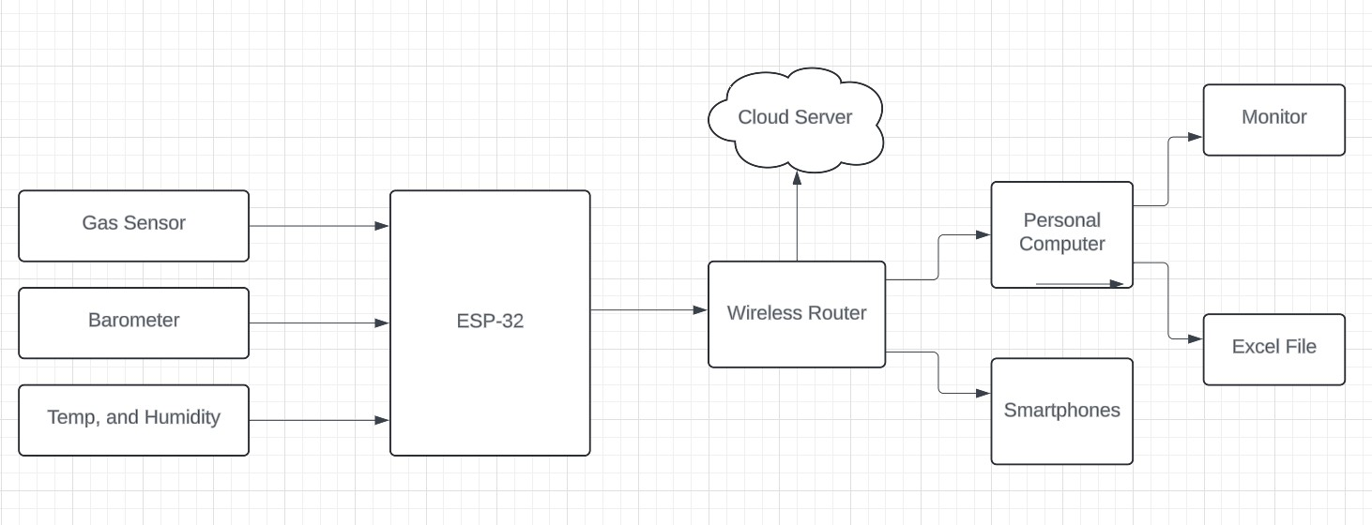

***Figure 3.1 Block diagram of Zephyr***

This block diagram provides an overview of the key components and their interactions within a weather station using an ESP32 microcontroller. The ESP32 acts as the central processing unit, interfacing with sensors, handling data processing, and managing wireless communication to transmit weather data to external systems for further analysis and utilization.It comprises of MQ 135,DHT 11,LCD display. External server or platform where weather data is transmitted for storage, analysis, and visualization. There exist various sensors like temperature sensors, humidity sensors, rain sensors and pressure sensor which are suitable for the full functioning of the system. These sensors collect and transmit data to a server via a Wi-Fi module to be stored and can be accessed on the webpage. These data are then analysed and used in predicting future data.

**3.2 Description of System Components**

1. **ESP32**

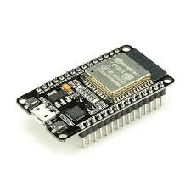

*Figure3.2 ESP 32*

The ESP32 is a versatile, low-cost, and power-efficient microcontroller with built-in Wi-Fi and Bluetooth capabilities, widely used for IoT applications. The ESP32's combination of dual-core processing, Wi-Fi and Bluetooth connectivity, rich peripheral set, low power consumption, security features, ease of development, and affordability make it a popular choice for developing IoT solutions, including smart home devices, environmental monitoring systems, industrial automation, and more.

1. **MQ-135**

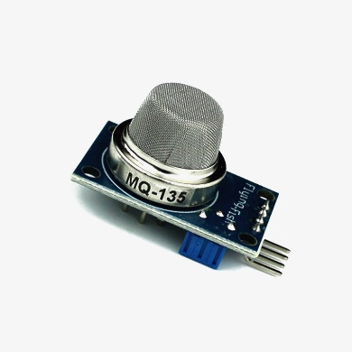

***Figure3.3 MQ-135***

The MQ135 is a gas sensor module capable of detecting a variety of air pollutants, commonly used for monitoring air quality in IoT applications.

1. **DHT-11**

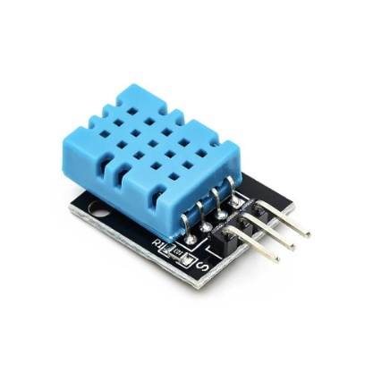

***Figure 1.4 DHT-11***

The DHT11 is a basic and cost-effective digital temperature and humidity sensor widely used in various electronic projects. The DHT11 remains popular for basic temperature and humidity sensing applications where cost-effectiveness and simplicity are prioritized over precision. It's commonly used in weather stations, climate monitoring systems, home automation projects, and educational demonstrations.

1. **LCD Display**

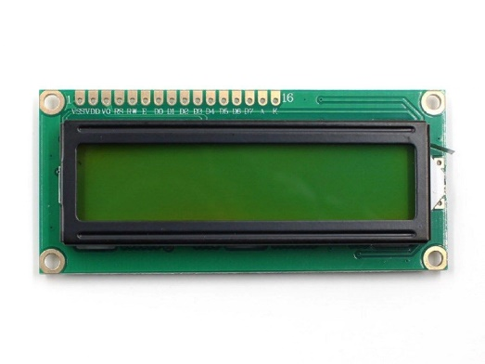

*Figure 1.5 LCD Display*

A Liquid Crystal Display (LCD) is a flat-panel display technology commonly used for displaying visual information in electronic devices such as digital watches, calculators, smartphones, computer monitors, and various embedded systems.

**3.3 Circuit Diagram**

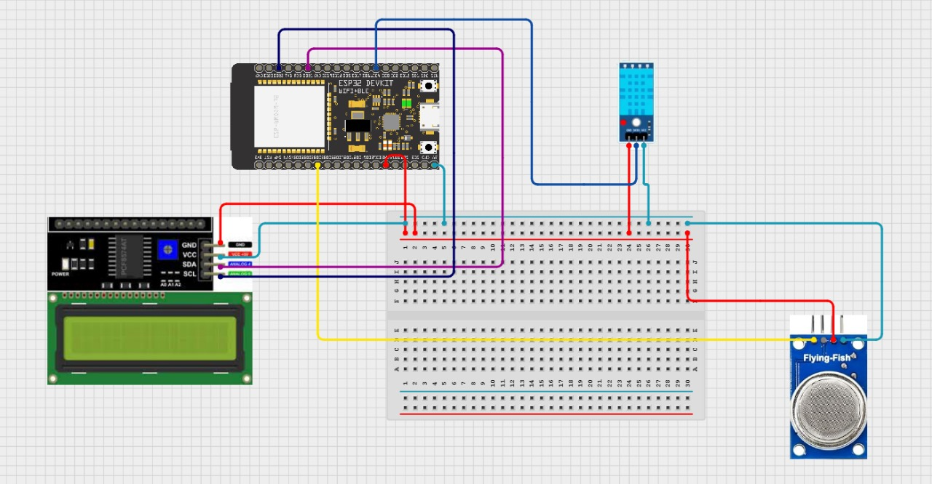

***Figure 3.8 Circuit diagram***

**3.4 Description of Circuit Diagram**

The ESP32 is a microcontroller that is commonly used for IoT projects. It can be used to create a weather station that measures temperature, humidity, pressure, and altitude. The data can then be sent to the cloud using Wi-Fi. The temperature and humidity sensor uses only one digital pin for communication, while the other two sensors use I2C communication. The I2C communication sensors are both connected to D21 (SDA) and D22 (SCL) pins on the ESP32. The weather station can be monitored from anywhere in the world using the IP address of ESP32.

The main advantages of Zephyr are:

* They provide real time and historical data on temperature,humidity,wind speed etc.
* Weather stations can be placed in specific locations providing localized weather data that might not be available from broader weather forecasts.
* They can detect sudden changes in weather conditions,allowing for early warnings of severe weather events like storms,hurricanes or tornadoes.

Some of the disadvantages are:

* Weather stations can be expensive to purchase, install and maintain, especially if high quality equipment is needed for accurate measurements.
* Weather stations require high callibrations,upkeepand sometimes repairs to ensure accurate data collection, which can b time consuming and costly.

**3.5 Cost of Materials**

**Table 3:1.Cost of Materials**

|  |  |  |  |  |
| --- | --- | --- | --- | --- |
| **Sl.no** | **Components** | **Specifications** | **Quantity** | **Price** |
| 1. | ESP32 |  | 1 | Rs. 799/- |
| 2. | LCD 16*2 I2C | 85*29.5*13.5mm | 1 | Rs. 159/- |
| 3. | MQ-135 | 0-4.2V | 1 | Rs.102/- |
| 4. | DHT-11 | 20-90 | 1 | Rs. 66/- |
| 5. | 470 ohm resistor | 350V,0.25W | 1 | Rs. 2/- |
| 6. | 1k ohm resistor | 0.25W,350V | 1 | Rs. 2/- |
| 7. | 10k ohm resisitor | 0.25W,5% | 1 | Rs. 2/- |
| 8. | USB micro b cable |  | 1 | Rs. 99/- |
| 9. | BMP 180 | 300-1100hpa | 1 | Rs. 37/- |
|  |  |  | **Total:** | **Rs. 1269/-** |

**CHAPTER 4**

**RESULT**

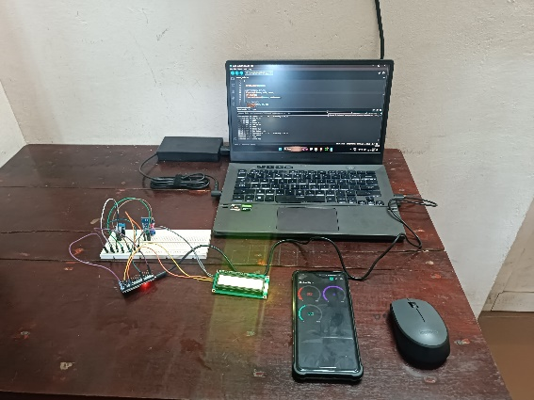

https[://](https://youtu.be/Qz9ptWYsETY?feature=shared)youtu.be/Qz9ptWYsETY?feature=shared

Weather stations provide comprehensive data on atmospheric conditions, including real-time and historical information on key parameters such as temperature, humidity, air pressure, wind speed, wind direction, precipitation, and occasionally supplementary metrics like UV index, dew point, and visibility. These data are collected and processed by sensors installed within the weather station infrastructure. The processed data can then be presented in various formats, facilitating analysis, visualization, and decision-making processes. This wealth of information enables stakeholders to better understand weather patterns, anticipate changes, and make informed decisions across a range of applications, from agriculture and transportation to urban planning and emergency management. By leveraging the data provided by weather stations, individuals and organizations can enhance their preparedness, response, and adaptation strategies in the face of changing environmental conditions.

**CHAPTER 5**

**CONCLUSION**

In conclusion, the integration of the ESP32, DHT11, MQ135, and Blynk IoT Cloud into an air quality monitoring system presents a significant advancement with tangible real-world applications. This system delivers precise and real-time data on crucial air quality parameters, including temperature, humidity, and pollutant levels, thereby empowering individuals, communities, and industries to make informed decisions concerning health, environmental impact, and safety measures.

The versatility of this system allows for its deployment across various settings, including smart homes, offices, industrial facilities, and urban planning initiatives. In smart homes, it enables residents to monitor indoor air quality, identify potential pollutants, and take proactive measures to safeguard their health and well-being. In offices and industrial facilities, it facilitates the implementation of pollution control measures, ensuring a safe and healthy working environment for employees.

Moreover, in urban planning, the data generated by this system can inform decision-makers about air quality trends, hotspots of pollution, and areas in need of intervention. By integrating air quality considerations into urban planning processes, cities can develop strategies to mitigate pollution, reduce exposure to harmful pollutants, and improve overall public health outcomes.

**REFERENCES**

[1]. **Mohamad Syafiq Mohamad Adenan, et al. “*Smart Smoke Detector*”,** [**https://doi.org/10.36079/lamintang.ijortas-0301.198**](https://doi.org/10.36079/lamintang.ijortas-0301.198)**, March 2021**

[2]. **Nikhil Komalapati, et al. “*Smart Fire Detection and Surveillance System Using IOT*”, 2021 International Conference on Artificial Intelligence and Smart Systems (ICAIS)**

[3]. **Uddesh U Naik et al. *“Iot Based Air Pollution Monitoring System*”, International Journal of Scientific Research & Engineering Trends Volume 9, Issue 3, May-Jun-2023**

[4]. **V. Hura, L. Monastyrskii, “*IoT-Based Solution for Detection of Air Quality using ESP32*”, ISSN 2710 – 1673 Artificial Intelligence 2023**

[5]. **Umar Muhammad et al. “*Environmental Condition Measurement system with a mini Weather Station using ESP32”*,** [**Vol. 21 No. 1 (2023): MEDIA ELEKTRIK**](https://journal.unm.ac.id/index.php/mediaelektrik/issue/view/50)

[6]. [**Rajinder Kumar M. Math**](https://ieeexplore.ieee.org/author/37086160736)**,**[**Nagaraj V. Dharwadkar**](https://ieeexplore.ieee.org/author/37591120700)**, “IoT Based Low-cost Weather Station and Monitoring System for Precision Agriculture in India”**

**APPENDIX**

#define BLYNK_TEMPLATE_ID "TMPLwToQUqRw"

#define BLYNK_TEMPLATE_NAME "Air Quality Monitoring"

#define BLYNK_AUTH_TOKEN "C8Y7T0Fr54QF8pdfQ5dZsdfhhSdiQBFLj8mYe"

#define BLYNK_PRINT Serial

#include <WiFi.h>

#include <BlynkSimpleEsp32.h>

#include <DHT.h>

#include <LiquidCrystal_I2C.h>

LiquidCrystal_I2C lcd(0x27, 16, 2);

byte degree_symbol[8] =

{

0b00111,

0b00101,

0b00111,

0b00000,

0b00000,

0b00000,

0b00000,

0b00000

};

char auth[] = BLYNK_AUTH_TOKEN;

char ssid[] = "WiFi Username"; // type your wifi name

char pass[] = "WiFi Password"; // type your wifi password

BlynkTimer timer;

int gas = 32;

int sensorThreshold = 100;

#define DHTPIN 4 //Connect Out pin to D2 in NODE MCU

#define DHTTYPE DHT11

DHT dht(DHTPIN, DHTTYPE);

void sendSensor()

{

float h = dht.readHumidity();

float t = dht.readTemperature(); // or dht.readTemperature(true) for Fahrenheit

if (isnan(h) || isnan(t)) {

Serial.println("Failed to read from DHT sensor!");

return;

}

int analogSensor = analogRead(gas);

Blynk.virtualWrite(V2, analogSensor);

Serial.print("Gas Value: ");

Serial.println(analogSensor);

// You can send any value at any time.

// Please don't send more that 10 values per second.

Blynk.virtualWrite(V0, t);

Blynk.virtualWrite(V1, h);

Serial.print("Temperature : ");

Serial.print(t);

Serial.print(" Humidity : ");

Serial.println(h);

}

void setup()

{

Serial.begin(115200);

//pinMode(gas, INPUT);

Blynk.begin(auth, ssid, pass);

dht.begin();

timer.setInterval(30000L, sendSensor);

//Wire.begin();

lcd.begin();

// lcd.backlight();

// lcd.clear();

lcd.setCursor(3,0);

lcd.print("Air Quality");

lcd.setCursor(3,1);

lcd.print("Monitoring");

delay(2000);

lcd.clear();

}

void loop()

{

Blynk.run();

timer.run();

float h = dht.readHumidity();

float t = dht.readTemperature(); // or dht.readTemperature(true) for Fahrenheit

int gasValue = analogRead(gas);

lcd.setCursor(0,0);

lcd.print("Temperature ");

lcd.setCursor(0,1);

lcd.print(t);

lcd.setCursor(6,1);

lcd.write(1);

lcd.createChar(1, degree_symbol);

lcd.setCursor(7,1);

lcd.print("C");

delay(4000);

lcd.clear();

lcd.setCursor(0, 0);

lcd.print("Humidity ");

lcd.print(h);

lcd.print("%");

delay(4000);

lcd.clear();

//lcd.setCursor(0,0);

// lcd.print(gasValue);

// lcd.clear();

Serial.println("Gas Value");

Serial.println(gasValue);

if(gasValue<1200)

{

lcd.setCursor(0,0);

lcd.print("Gas Value: ");

lcd.print(gasValue);

lcd.setCursor(0, 1);

lcd.print("Fresh Air");

Serial.println("Fresh Air");

delay(4000);

lcd.clear();

}

else if(gasValue>1200)

{

lcd.setCursor(0,0);

lcd.print(gasValue);

lcd.setCursor(0, 1);

lcd. Print("Bad Air");

Serial.println("Bad Air");

delay(4000);

lcd.clear();

}

if(gasValue > 1200)

 }